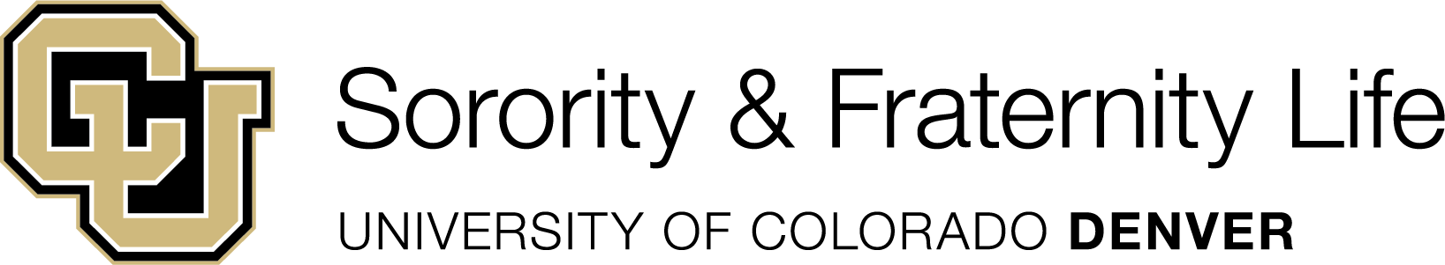

Spring 2025 New Member Recruitment Calendar
Week | Date / Due Date | Function / Process / Notes
0 | January 6, 2025 | The SFL Participant Recruitment Registration Form opens. All CU Denver student participants are required to fill out this form to go through recruitment.
1 | January 20, 2025 | - Deadline to submit the Recruitment Events Planning Form. This form lays out your recruitment plan in totality.  - Groups must also submit each event in MyLynx, at least 2 weeks in advance of event.  - Forms will be available on MyLynx.
1 | January 21, 2025 | First Day of Fall Semester Classes
0-3 | January 6 – February 7, 2025 | Student Life Marketing of SFL Recruitment on behalf of all SFL organizations
3 | February 3 and 5, 2025 | SFL Recruitment Information Sessions – 5pm Zoom Link  - These sessions will be offered virtually in the evenings to facilitate the greatest access for our students  - All chapters are expected to have one representative attend to do an overview of your chapter or lead a breakout room info session.
3 | February 7, 2025 | SFL Participant Recruitment Registration Form Closes 5pm
4 | February 8 – 9, 2025 | Student Life will check 1) full time student status, 2) minimum 2.5 cumulative GPAs, and 3) conduct records with the Student Conduct Office
4 | February 10, 2025 | Groups will receive list of SFL recruitment eligible students by 5pm.
4-16 | February 10 – May 9, 2025 | Groups may conduct their recruitment process and new member education program.  - Chapters will submit the Recruitment & New Member Report Form within 48 hours of the end of their formal recruitment program of events. This should be received prior to the beginning of your new member education program.  - Chapters will submit the New Member Education/Intake Program Registration Form 4 weeks in advance of start of your new member education program. Initiation should take place no later than the last day of classes, Dec 8, 2023, to accommodate final exams and allow students to complete their semester academic work.
10 | March 24 – 30, 2025 | SPRING BREAK
11 | April 4, 2025 | No formal recruitment may occur after this date (COB)
16 | May 9, 2025 | Last Day of Fall Semester Classes: no events after this date

NOTES:
- Please refer to the Sorority & Fraternity Life manual for more information on recruitment.
- Please contact Addison Lemons, Assistant Director for Student Organizations if you have any questions.

