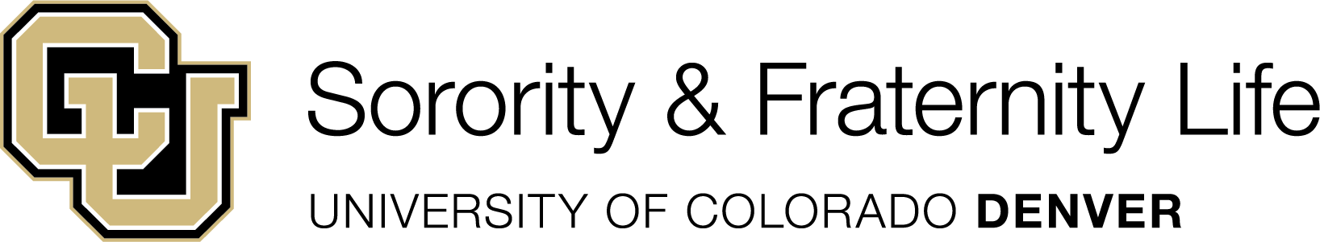

Spring 2026 New Member Recruitment Calendar
Week | Date / Due Date | Function / Process / Notes
0 | January 5, 2026 | The SFL Participant Recruitment Registration Form opens.
0 | January 5, 2026 | - Deadline to submit the Recruitment Events Planning Form. This form lays out your recruitment plan in totality.  - Groups must also submit each event in MyLynx, at least 2 weeks in advance of event.  - Forms will be available on MyLynx.
1 | January 20, 2026 | First Day of Spring Semester Classes
0-3 | January 5 – Feb 6, 2026 | Student Life Marketing of SFL Recruitment on behalf of all SFL organizations
3 | February 6, 2026 | SFL Participant Recruitment Registration Form Closes 5pm
4 | February 7 – 8, 2026 | Student Life will check 1) full time student status, 2) minimum 2.5 cumulative GPAs
4 | February 9, 2026 | Groups will receive list of SFL recruitment eligible students by 5pm.
4-16 | February 7 – May 8, 2026 | Groups may conduct their recruitment process and new member education program.  - Chapters will submit the Recruitment & New Member Report Form within 48 hours of the end of their formal recruitment program of events. This should be received prior to the beginning of your new member education program.  Chapters will submit the New Member Education/Intake Program Registration Form 4 weeks in advance of start of your new member education program. Initiation should take place no later than the last day of classes, May 8, 2026, to accommodate final exams and allow students to complete their semester academic work.
11 | April 3, 2026 | No formal recruitment may occur after this date (COB)
15 | March 23-29, 2026 | SPRING BREAK
16 | May 8, 2026 | Last Day of Spring Semester Classes: no events after this date

Please contact Addison Lemons, Assistant Director for Student Organizations if you have any questions.

