AGENDA
- Welcome & Introductions
- What is Advancement?
- Advancement Resources
- Donor Continuum – Relationship Development
- Creating an Elevator Pitch – Telling Your Story
- What is a Comprehensive Campaign?
- Next Steps

ACTIVITY #1: TWO TRUTHS & A LIE – AN INTERACTIVE POLL
Scan the QR Code on the screen to join the poll group.
Note: You will be taken to a sign in page. Choose the SKIP button to join. Answers will be anonymous.

ACTIVITY #2: CASE & DISCUSSION WORK
Your table will be assigned one of the Case Examples below. Discuss your assigned Case as a group, using the Discussion Questions as a guide. You will be asked to share your findings to the larger group!

Case Example #1: IDENTIFICATION
Dr. Martinez maintains regular contact with Alex Johnson (former student and now alumnus) through email and invitations to department events. She also engages with Alex on LinkedIn, sharing updates about departmental achievements and opportunities for alumni involvement.
Dr. Martinez sees a LinkedIn update where Alex mentions he has recently been promoted. The promotion includes a new project he is leading that involves significant funding for environmental education and conservation. Dr. Martinez notes Alex’s enthusiasm and growing influence in the field.
Discussion Questions:
- How can Dr. Martinez identify whether Alex might be a good prospect for a major gift?
- What steps should Dr. Martinez take to involve the Advancement office in exploring this opportunity?
- How can Dr. Martinez deepen the relationship with Alex?
Case Example #2: CULTIVATION
Dr. John Miller, a faculty member, has been engaging with an alumnus who recently expressed interest in supporting a new research initiative. The alumnus has attended several department events and has been in regular contact with Dr. Miller, but no formal request for support has been made yet.
Discussion Questions:
- What actions can Dr. Miller take to further cultivate the relationship with the alumnus?
- How can Dr. Miller collaborate with the advancement office to ensure the alumnus is appropriately engaged and informed?
- What are some potential next steps to move the alumnus closer to making a gift?
Case Example #3: SOLICITATION
Dr. Emily Carter, a professor, has been working closely with a major donor on a project that aligns with the donor's interests. The donor has indicated they are ready to make a significant contribution, but Dr. Carter feels uncomfortable directly asking for a specific amount.
Discussion Questions:
- How can Dr. Carter approach the solicitation in a way that aligns with the donor’s interests and feels comfortable for both parties?
- What role should the advancement office play in the solicitation process?
- How can Dr. Carter ensure that the solicitation is strategic and effective without jeopardizing the relationship?

Case Example #4: STEWARDSHIP
Dr. Sarah Lee, a faculty member, recently received a large donation from a donor who is passionate about entrepreneurship. The donation is funding a new program, and Dr. Lee wants to ensure the donor feels appreciated and remains engaged in the program’s success.
Discussion Questions:
- What steps can Dr. Lee take to steward this donor and maintain a long-term relationship?
- How can the impact of the donor’s gift be communicated effectively?
- What ongoing opportunities for engagement can Dr. Lee offer to the donor to keep them invested in the program?
5 FINGER MESSAGING
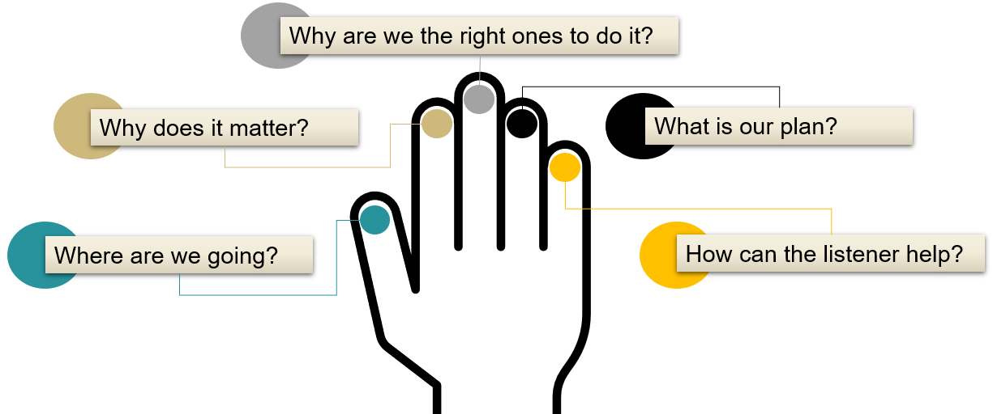
Hunt (2012)

Hunt, P.C. (2012) Development for academic leaders: A practical guide for fundraising success. New York: John Wiley & Sons.

ACTIVITY #3: STORY TELLING WITH 5 FINGER MESSAGING
For this activity, discuss at your table how you can use 5 Finger Messaging to tell your story. Refer to our example below to help you along. We will ask for volunteers to share to the larger group!
“Student Support Services at CU Denver is dedicated to empowering first-generation, low-income students, and those with disabilities to achieve academic success and reach their full potential. Our program offers comprehensive support, including academic guidance, peer mentoring, career preparation, and financial aid assistance, all designed to increase retention and graduation rates. With a strong history of fostering a supportive community, SSS ensures that students not only succeed in their studies but also thrive personally and professionally. By supporting SSS, you help provide critical resources and create an inclusive environment where underrepresented students can excel and pave their way to graduation. Your contribution enables us to continue making a significant impact on student success.”

Why does it matter?
Where are we going?
How can the listener help?
What is our plan?
Why are we the right ones to do it?
‘With a strong history of fostering a supportive community, SSS ensures that students not only succeed in their studies but also thrive personally and professionally.’
‘Our program offers comprehensive support, including academic guidance, peer mentoring, career preparation, and financial aid assistance, all designed to increase retention and graduation rates.’
‘Student Support Services at CU Denver is dedicated to empowering first-generation, low-income students, and those with disabilities to achieve academic success and reach their full potential.’
‘With a strong history of fostering a supportive community, SSS ensures that students not only succeed in their studies but also thrive personally and professionally.’
‘By supporting SSS, you help provide critical resources and create an inclusive environment where underrepresented students can excel and pave their way to graduation.’

KEY TAKEAWAYS
Advancement Definitions & Functions:
- Prospect Research: Process of identifying and evaluating potential donors to assess their ability and willingness to contribute.
- Alumni Relations: Engaging with alumni to foster a strong network.
- Fundraising/Major Gifts: Strategies for securing financial support.
- Planned Giving: Planned giving is arranging future donations, often through a will or financial plan.
- Annual Giving / Crowdfunding: Ways people raise money regularly or for special projects by asking for smaller donations from many supporters.
- Industry & Foundation Relations: Building partnerships with businesses and grant-giving organizations to secure support and funding.
- Donor Stewardship: Maintaining and strengthening relationships with donors to encourage continued support.
- Strategic Communications: Promoting the university’s achievements and initiatives.
- Event Planning & Execution
Comprehensive Campaign:
- Understanding the phases and expected impacts.
- Importance of each phase in achieving the campaign’s goals.
Relationship Development:
- Identification: Finding potential donors.
- Cultivation: Building relationships.
- Solicitation: Making the case for support.
- Stewardship: Maintaining and deepening relationships.
Elevator Pitch Development:
- Focus on clarity, emotional connection, and impact.
- Use the $1 million scenario to think big and articulate your vision.
- 5 Finger Method:
  - Where are we going?
  - Why does it matter?
  - Why are we the right ones to do it?
  - What is our plan?
  - How can the listener help?
Upcoming Steps:
- Workshop Surveys
- Follow Up Email
- Spring Workshops

